**JMeter Performance Test NK 21/10/2017**

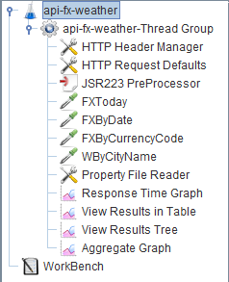

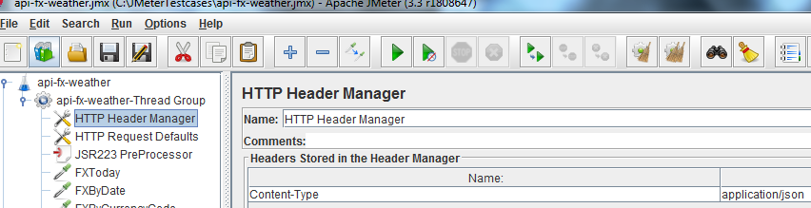

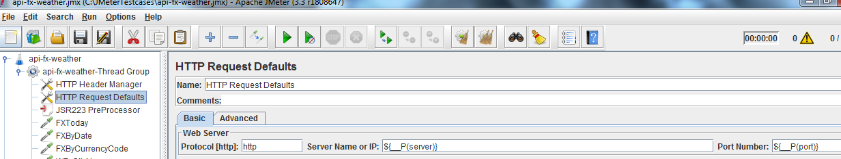

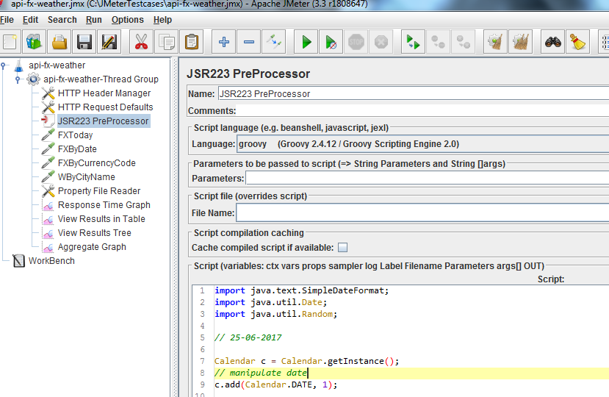

import java.text.SimpleDateFormat;

import java.util.Date;

import java.util.Random;

// 25-06-2017

Calendar c = Calendar.getInstance();

// manipulate date

c.add(Calendar.DATE, 1);

def start = c.getTime();

def end = Date.parse('dd-MM-yyyy', '25-06-2017')

Date date= randomDate(start..end)

SimpleDateFormat df = new SimpleDateFormat("dd-MM-yyyy");

String formattedDate = df.format(date);

// Resulting date will be in fxdate

vars.put("api-fx-weather.fx_dt",formattedDate);

// getting the random currency code

def randomNum = (new Random()).nextInt(3);

def currencyArr = ["CAD", "GBP", "HKD","USD"] as String[];

def cityArr = ["London", "Manchester", "Luton","Cardiff"] as String[];

vars.put("code",currencyArr[randomNum]);

vars.put("city",cityArr[randomNum]);

Date randomDate(Range<Date> range) {

range.from + new Random().nextInt(range.to - range.from + 1)

}

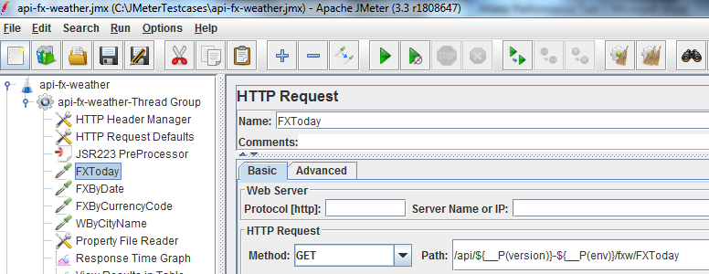

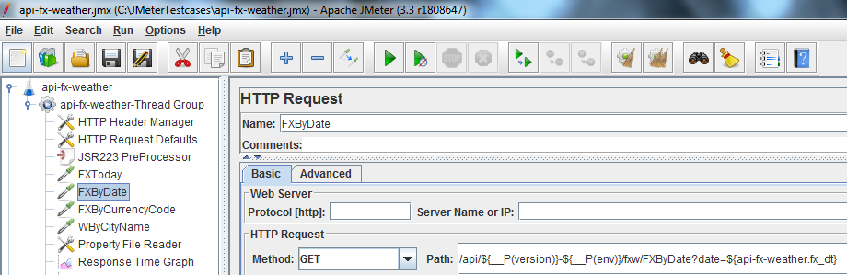

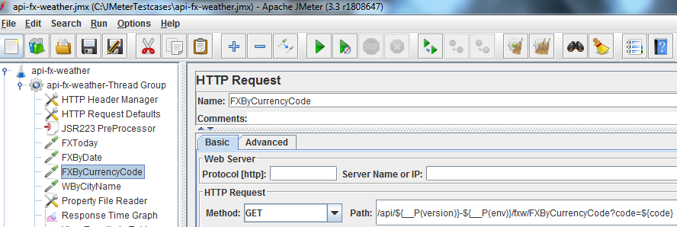

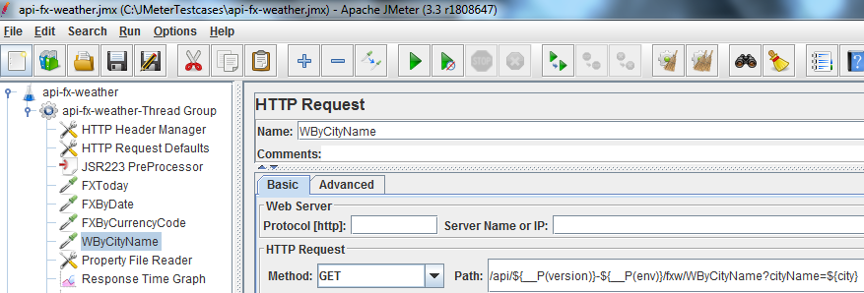

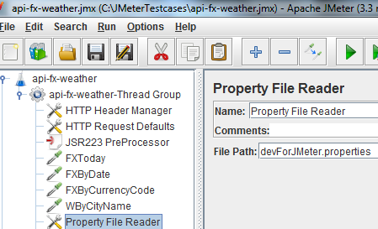

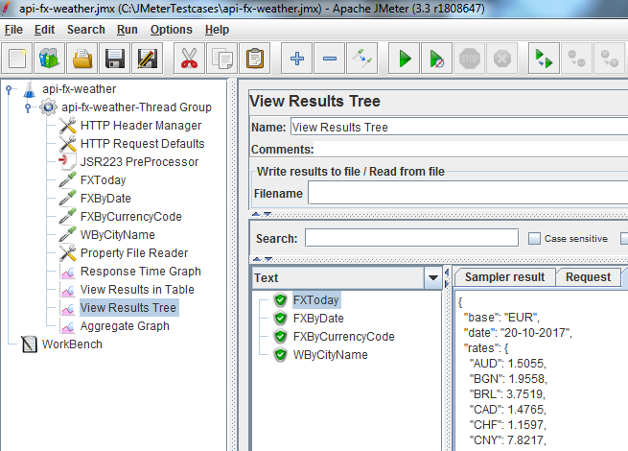**Page 4 of 5**

